Database Evolution for M04\_Bookit

Contents

[Introduction 4](#_Toc478384459)

[Methodology 4](#_Toc478384460)

[ERD 1 – 01/12/2016 5](#_Toc478384461)

[ERD 2 – 01/12/2016 6](#_Toc478384462)

[ERD 3 – 08/12/2016 7](#_Toc478384463)

[ERD 4 – 24/01/2017 8](#_Toc478384464)

[ERD 5 – 14/02/2017 9](#_Toc478384466)

[ERD 6 – 14/02/2017 10](#_Toc478384467)

[ERD 7 – 22/02/2017 11](#_Toc478384468)

[ERD 8 – 07/03/2017 12](#_Toc478384469)

[First DDL 13](#_Toc478384470)

[Final DDL from Dump 15](#_Toc478384471)

[Final Data Dictionary 23](#_Toc478384472)

# Introduction

Throughout the project Matt kept a diary of the changes to the database design using and saved the resulting Entity Relationship Diagrams for reference. Initially Matt took the inspiration for the first database design for the Library from previous work where he created an Ecommerce shop. Although this was a good starting position it soon became apparent that the amount of detail being stored on this system was substantially more. Also the premise of a shop is that there are generally multiple items of a particular type, whereas this system had unique items that once lent out were missing from the lendable items.

# Methodology

Matt had a very rough sketch of the first ERD of a shop that was added to and edited as the project needed it to change. None of us knew exactly what we needed at the beginning of the project, so this iterative and fluid building technique was essential for the smooth progress of the project. Keeping a track of this progress it can be shown that although the attributes changed from the beginning the structure didn’t change that much. `

Creating the initial Database Definition Language from the first ERD Matt used a simple text editor to write the .sql code which was then uploaded to our database space on dragon server. After this stage additions, edits and removal of Tables and Attributes was performed from the command line on dragon server.

## ERD 1 – 01/12/2016

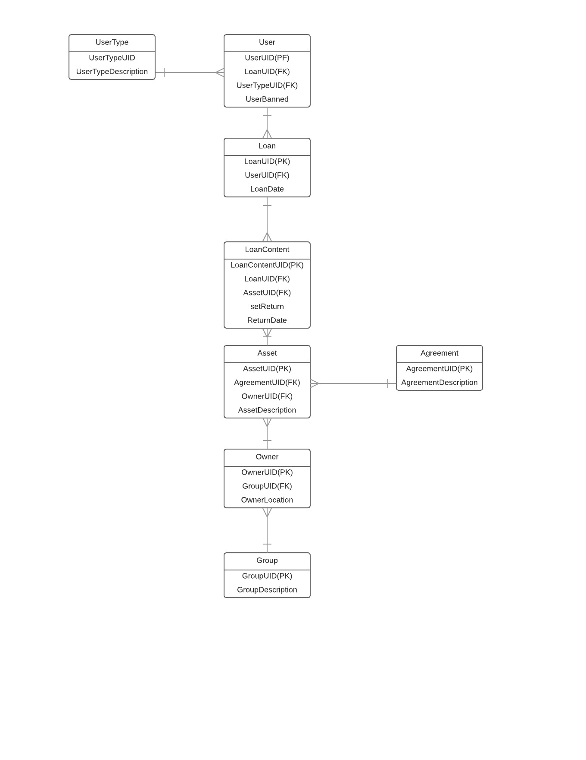

## ERD 2 – 01/12/2016

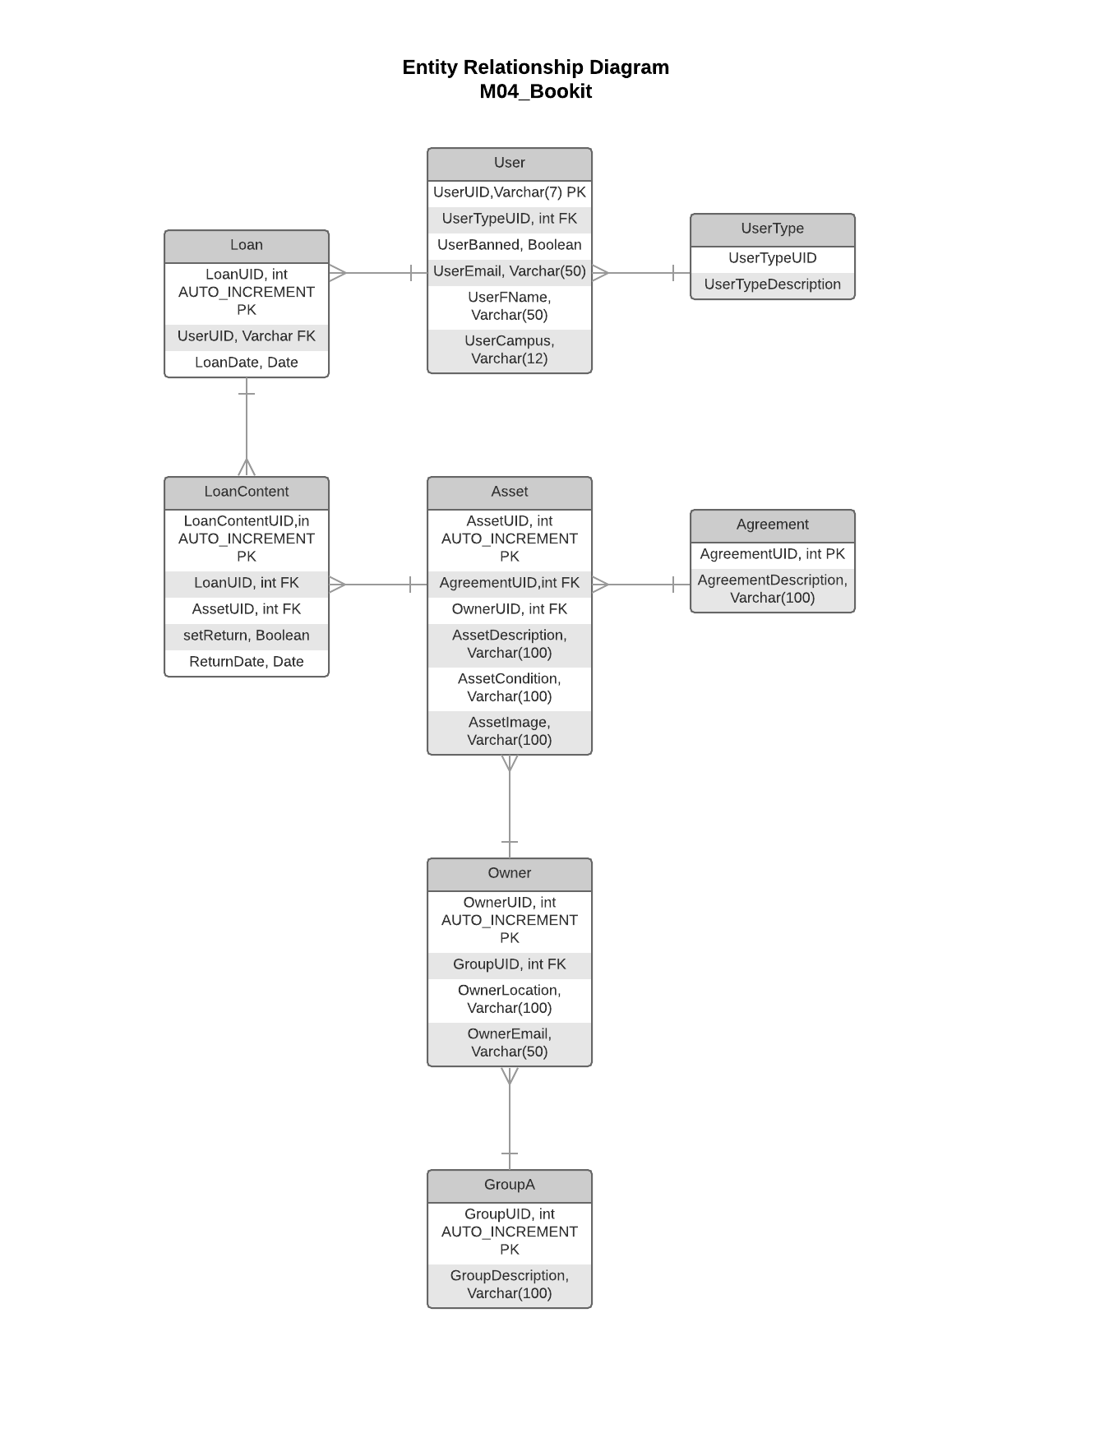

1. Needed to store more details of the User

2. Needed to store the Condition and a place to store the image of the Asset

3. Needed a place for the Owners Email

## ERD 3 – 08/12/2016

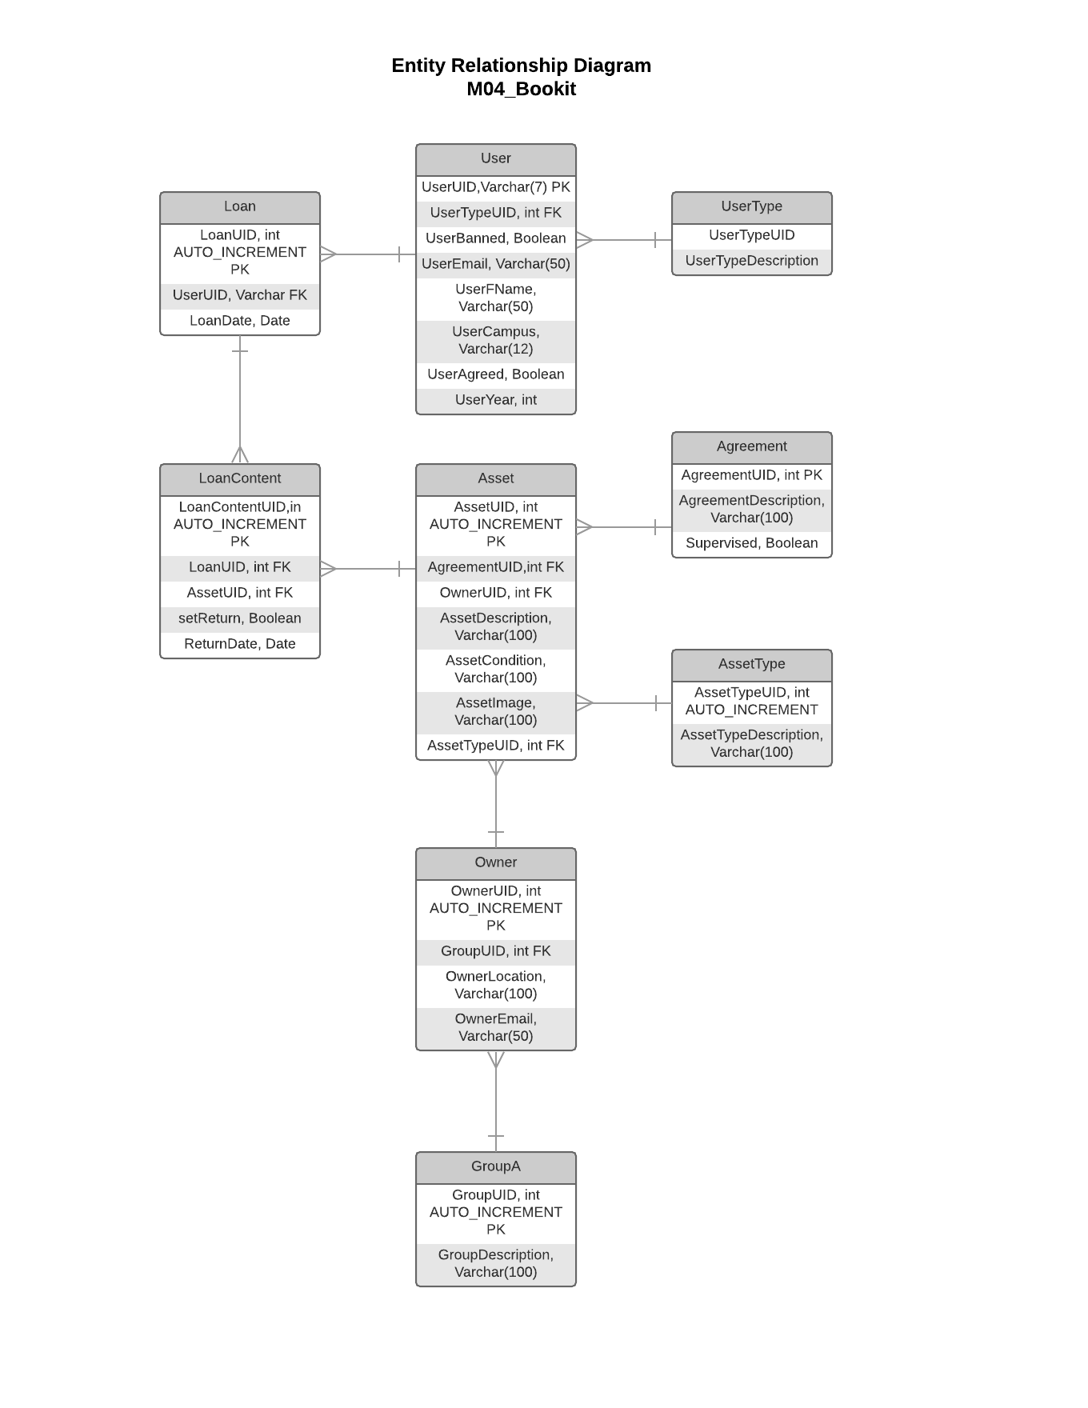

1. Needed to store whether the User has signed up to the conditions of the site and the place for the Users Year to be stored

2. Needed to store whether the connected asset to this agreement requires to be supervised when borrowing asset

## ERD 4 – 24/01/2017

## X:\public_html\CO600 Folder imported from Google Drive\Database Design\ERD of Database - 24.1.17.png

1. Needed to store how many current loans the user has

2. Needed to store the restriction an asset might have, for example tutors only

3. Storing a place to say this Asset is in some user’s basket to stop 2 people borrowing the same item

4. Store a place for the Owners name

## ERD 5 – 14/02/2017

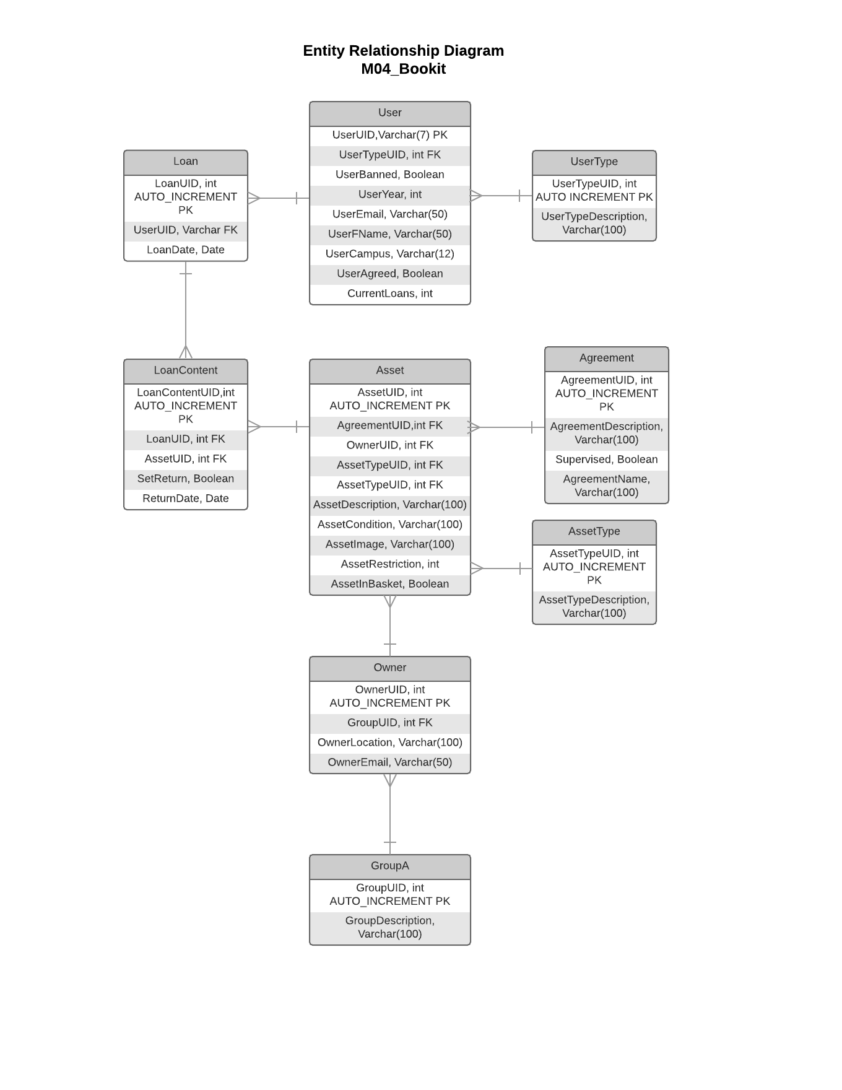

1. Gave the Agreement a name so that it quickly be established what the agreement did for button purposes

2. Removed Owners name as it was duplication from the User table

## ERD 6 – 14/02/2017

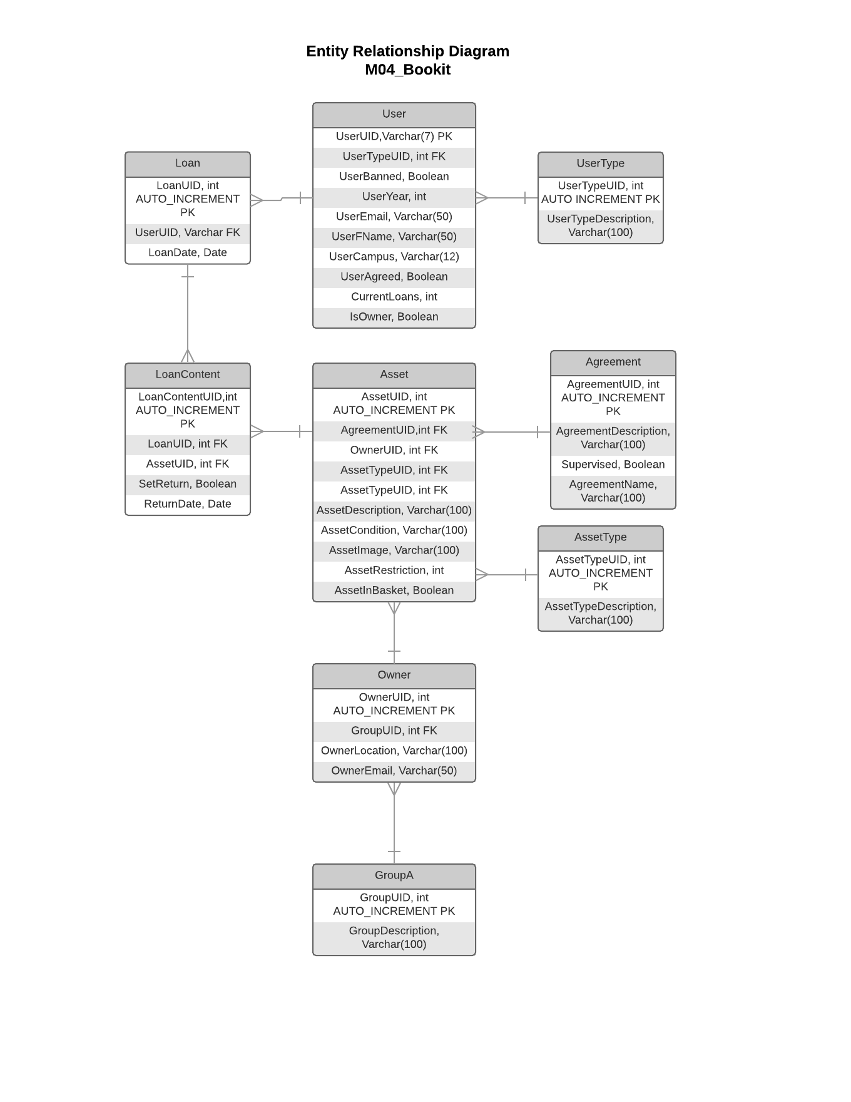

1. Added an Attribute to denote whether a user is also an owner

## ERD 7 – 22/02/2017

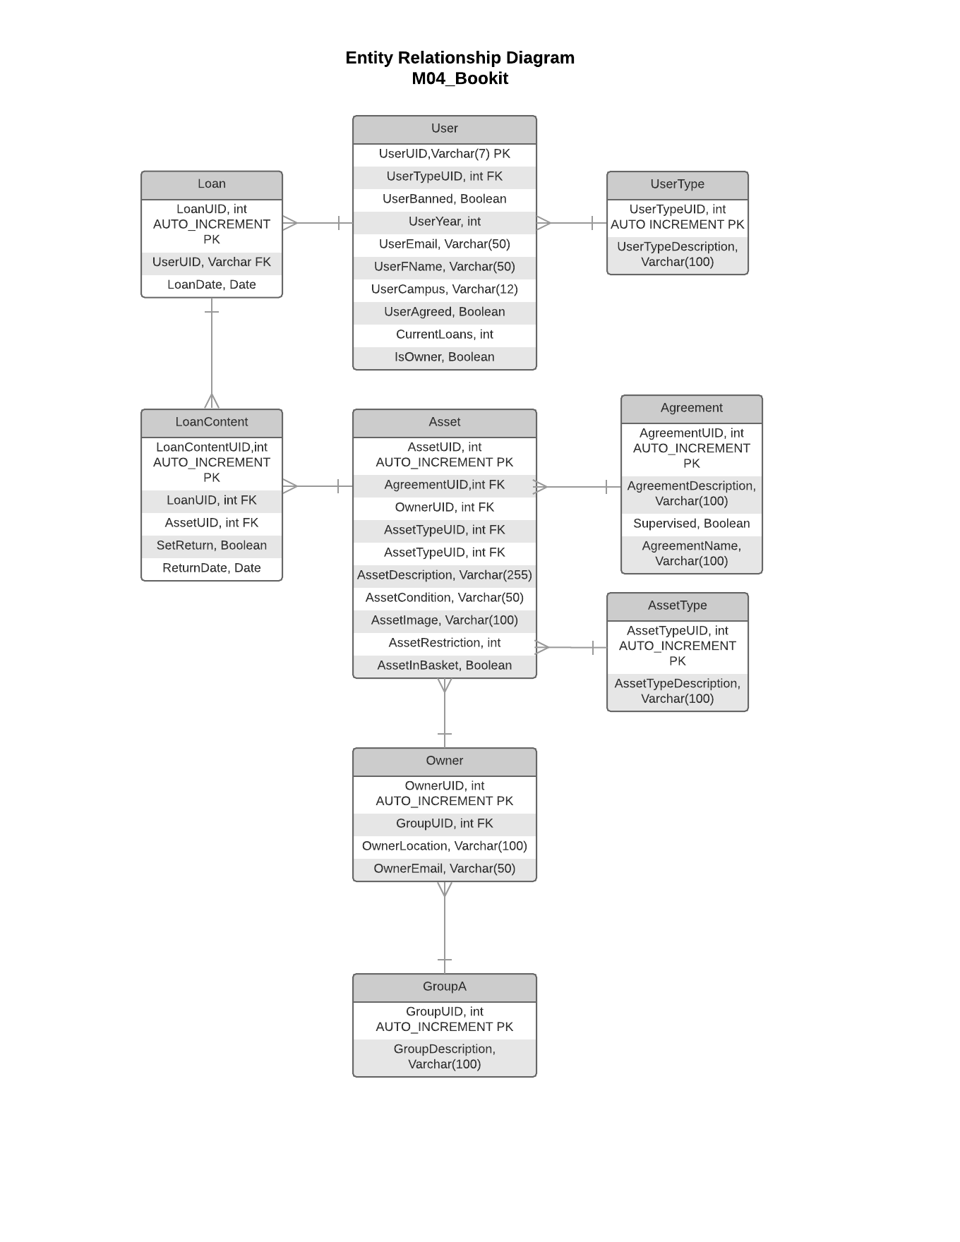

1. Changed the length stored in AssetDescription and AssetCondition to make sure all data is held

## ERD 8 – 07/03/2017

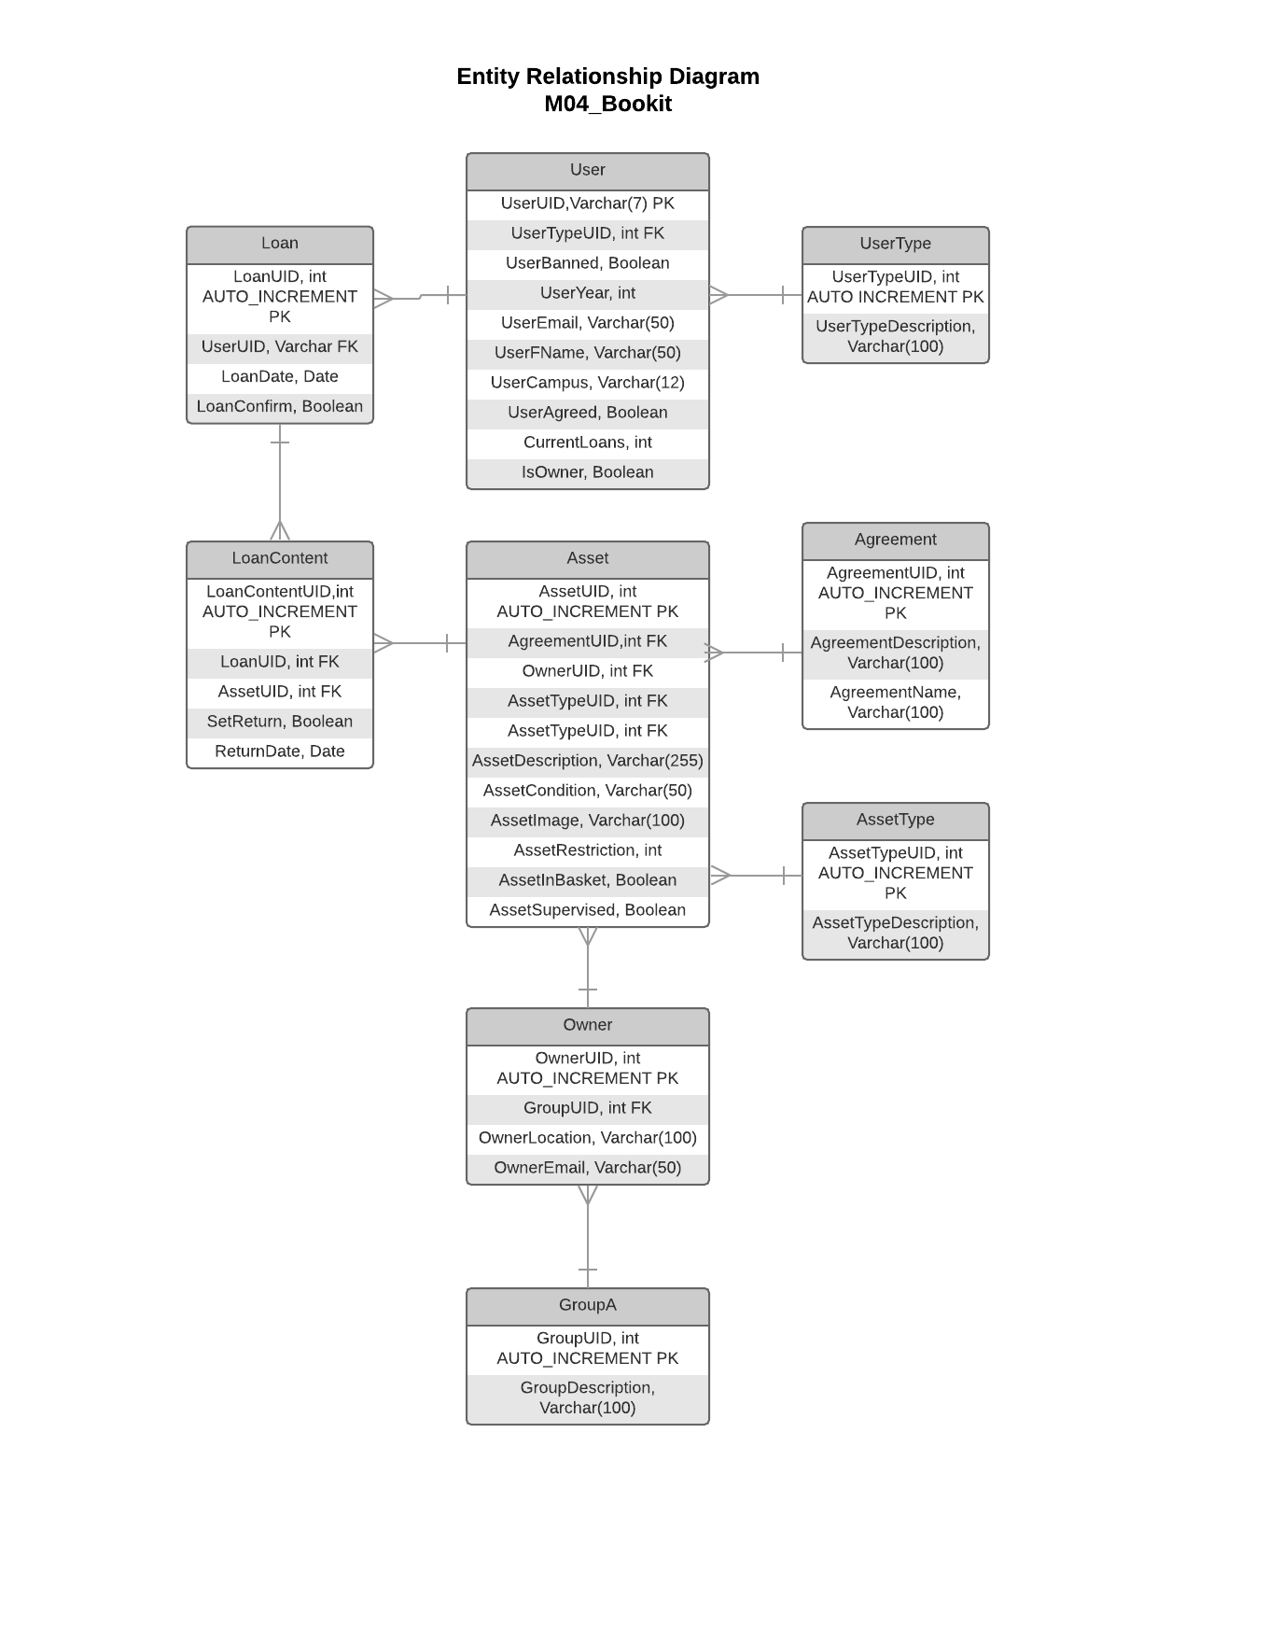

1. Added LoanConfirm Attribute to Loan allowing us to establish if this loan is real or not

2. Removed Supervised from Agreement and added it to the Asset table as it made much more sense to have the Asset supervised rather than the Agreement

# First DDL

CREATE TABLE Agreement (

AgreementUID int AUTO\_INCREMENT,

AgreementDescription VARCHAR(100),

PRIMARY KEY (AgreementUID)

);

CREATE TABLE Asset (

AssetUID int AUTO\_INCREMENT,

AgreementUID int,

OwnerUID int,

AssetDescription VARCHAR(100),

PRIMARY KEY(AssetUID),

FOREIGN KEY(AgreementUID) REFERENCES Agreement(AgreementUID)

);

CREATE TABLE UserType (

UserTypeUID int AUTO\_INCREMENT,

UserTypeDescription VARCHAR(100),

PRIMARY KEY (UserTypeUID)

);

CREATE TABLE GroupA (

GroupUID int AUTO\_INCREMENT,

GroupDescription VARCHAR (100),

PRIMARY KEY (GroupUID)

);

CREATE TABLE Owner (

OwnerUID int AUTO\_INCREMENT,

GroupUID int,

OwnerLocation VARCHAR (100),

PRIMARY KEY (OwnerUID),

FOREIGN KEY (GroupUID) REFERENCES GroupA(GroupUID)

);

CREATE TABLE User (

UserUID VARCHAR(7),

UserTypeUID int,

UserBanned BOOLEAN,

PRIMARY KEY (UserUID),

FOREIGN KEY (UserTypeUID) REFERENCES UserType(UserTypeUID)

);

CREATE TABLE Loan (

LoanUID int AUTO\_INCREMENT,

UserUID VARCHAR,

LoanDate Date,

PRIMARY KEY (LoanUID),

FOREIGN KEY (UserUID) REFERENCES User(UserUID)

);

CREATE TABLE LoanContent (

LoanContentUID int AUTO\_INCREMENT,

LoanUID int,

AssetUID int,

setReturn Boolean,

ReturnDate Date,

PRIMARY KEY (LoanContentUID),

FOREIGN KEY (LoanUID) REFERENCES Loan(LoanUID),

FOREIGN KEY (AssetUID) REFERENCES Asset(AssetUID)

);

# Final DDL from Dump

-- MySQL dump 10.13 Distrib 5.7.15, for Linux (x86\_64)

--

-- Host: dragon.kent.ac.uk Database: m04\_bookit

-- ------------------------------------------------------

-- Server version 5.5.53-0ubuntu0.14.04.1

/\*!40101 SET @OLD\_CHARACTER\_SET\_CLIENT=@@CHARACTER\_SET\_CLIENT \*/;

/\*!40101 SET @OLD\_CHARACTER\_SET\_RESULTS=@@CHARACTER\_SET\_RESULTS \*/;

/\*!40101 SET @OLD\_COLLATION\_CONNECTION=@@COLLATION\_CONNECTION \*/;

/\*!40101 SET NAMES utf8 \*/;

/\*!40103 SET @OLD\_TIME\_ZONE=@@TIME\_ZONE \*/;

/\*!40103 SET TIME\_ZONE='+00:00' \*/;

/\*!40014 SET @OLD\_UNIQUE\_CHECKS=@@UNIQUE\_CHECKS, UNIQUE\_CHECKS=0 \*/;

/\*!40014 SET @OLD\_FOREIGN\_KEY\_CHECKS=@@FOREIGN\_KEY\_CHECKS, FOREIGN\_KEY\_CHECKS=0 \*/;

/\*!40101 SET @OLD\_SQL\_MODE=@@SQL\_MODE, SQL\_MODE='NO\_AUTO\_VALUE\_ON\_ZERO' \*/;

/\*!40111 SET @OLD\_SQL\_NOTES=@@SQL\_NOTES, SQL\_NOTES=0 \*/;

--

-- Table structure for table `Agreement`

--

DROP TABLE IF EXISTS `Agreement`;

/\*!40101 SET @saved\_cs\_client = @@character\_set\_client \*/;

/\*!40101 SET character\_set\_client = utf8 \*/;

CREATE TABLE `Agreement` (

`AgreementUID` int(11) NOT NULL AUTO\_INCREMENT,

`AgreementDescription` varchar(200) COLLATE utf8\_unicode\_ci DEFAULT NULL,

`AgreementName` varchar(100) COLLATE utf8\_unicode\_ci DEFAULT NULL,

PRIMARY KEY (`AgreementUID`)

) ENGINE=InnoDB AUTO\_INCREMENT=33 DEFAULT CHARSET=utf8 COLLATE=utf8\_unicode\_ci;

/\*!40101 SET character\_set\_client = @saved\_cs\_client \*/;

--

-- Dumping data for table `Agreement`

--

LOCK TABLES `Agreement` WRITE;

/\*!40000 ALTER TABLE `Agreement` DISABLE KEYS \*/;

INSERT INTO `Agreement` VALUES (3,'ajax/Pages/Inventory/Agreements/EEG\_Agreement.txt','EEG Agreement'),(4,'ajax/Pages/Inventory/Agreements/Ians\_Agreement.txt','Ians Agreement'),(5,'ajax/Pages/Inventory/Agreements/Matteo\_Agreement.txt','Matteo Agreement'),(6,'ajax/Pages/Inventory/Agreements/none.txt','None'),(26,'ajax/Pages/Inventory/Agreements/Matts\_test\_agreement.txt','Matts Test Agreement'),(30,'ajax/Pages/Inventory/Agreements/Matts\_special\_agreement.txt','matts very special agreement'),(31,'ajax/Pages/Inventory/Agreements/Matts\_special\_agreement3.txt','Matts even more special'),(32,'ajax/Pages/Inventory/Agreements/General Agreement.txt','General Agreement');

/\*!40000 ALTER TABLE `Agreement` ENABLE KEYS \*/;

UNLOCK TABLES;

--

-- Table structure for table `Asset`

--

DROP TABLE IF EXISTS `Asset`;

/\*!40101 SET @saved\_cs\_client = @@character\_set\_client \*/;

/\*!40101 SET character\_set\_client = utf8 \*/;

CREATE TABLE `Asset` (

`AssetUID` int(11) NOT NULL AUTO\_INCREMENT,

`AgreementUID` int(11) DEFAULT NULL,

`OwnerUID` varchar(7) COLLATE utf8\_unicode\_ci DEFAULT NULL,

`AssetTypeUID` int(11) DEFAULT NULL,

`AssetDescription` varchar(255) COLLATE utf8\_unicode\_ci DEFAULT NULL,

`AssetCondition` varchar(50) COLLATE utf8\_unicode\_ci DEFAULT NULL,

`AssetImage` varchar(100) COLLATE utf8\_unicode\_ci DEFAULT NULL,

`AssetRestriction` int(11) DEFAULT NULL,

`AssetInBasket` tinyint(1) DEFAULT NULL,

`AssetSupervised` tinyint(1) DEFAULT NULL,

PRIMARY KEY (`AssetUID`),

KEY `AgreementUID` (`AgreementUID`),

KEY `OwnerUID` (`OwnerUID`),

KEY `AssetTypeUID` (`AssetTypeUID`),

CONSTRAINT `Asset\_ibfk\_1` FOREIGN KEY (`AgreementUID`) REFERENCES `Agreement` (`AgreementUID`),

CONSTRAINT `Asset\_ibfk\_2` FOREIGN KEY (`OwnerUID`) REFERENCES `Owner` (`OwnerUID`),

CONSTRAINT `Asset\_ibfk\_3` FOREIGN KEY (`AssetTypeUID`) REFERENCES `AssetType` (`AssetTypeUID`)

) ENGINE=InnoDB AUTO\_INCREMENT=531 DEFAULT CHARSET=utf8 COLLATE=utf8\_unicode\_ci;

/\*!40101 SET character\_set\_client = @saved\_cs\_client \*/;

--

-- Dumping data for table `Asset`

--

LOCK TABLES `Asset` WRITE;

/\*!40000 ALTER TABLE `Asset` DISABLE KEYS \*/;

INSERT INTO `Asset` VALUES (485,6,'jd601',1,'HTML & CSS: Design and Build Web Sites','1','41Z2swEmwaL.\_SX396\_BO1,204,203,200\_.jpg',1,0,0),(486,6,'jd601',1,'Get Coding! Learn HTML, CSS, and JavaScript','1','51NKW5F7stL.\_SX441\_BO1,204,203,200\_.jpg',1,0,0),(487,6,'jd601',1,'PROGRAMMING For BEGINNERS','1','41zK+7W-zYL.\_SX331\_BO1,204,203,200\_.jpg',1,0,0),(488,6,'jd601',1,'Adobe Dreamweaver CCClassroom in a Book','1','51dwah9RGcL.\_SX398\_BO1,204,203,200\_.jpg',1,0,0),(489,6,'jd601',1,'Html: HTML & CSS: For Beginners:','1','51aNrxrIdtL.jpg',1,0,0),(490,6,'jd601',1,'Programming: Computer Programming For Beginners','1','517iFCgYSFL.\_SX331\_BO1,204,203,200\_.jpg',1,0,0),(491,6,'jd601',1,'C++: The Ultimate Crash Course to Learning the Basics ','1','41O0bhml1vL.jpg',1,0,0),(492,6,'jd601',1,'Python: Learn Python Programming','1','51b-ObEb3ML.jpg',1,0,0),(493,6,'jd601',1,'HTML5 in easy steps','1','51cXh98-VFL.\_SX401\_BO1,204,203,200\_.jpg',1,0,0),(495,6,'jd601',1,'Programming: HTML: Programming','1','412aGWpk7wL.jpg',1,0,0),(496,6,'jd601',1,'C Programming Language: A Step by Step Beginner\'s Guide','1','51brRiwC0ML.\_SX331\_BO1,204,203,200\_.jpg',1,0,0),(497,6,'jd601',1,'HTML and CSS: Visual QuickStart Guide ','1','514TTsUZ8uL.\_SX387\_BO1,204,203,200\_.jpg',1,0,0),(498,6,'jd601',1,'Advanced JAVA: For Beginners','1','41uN3C6izCL.jpg',1,0,0),(499,3,'jd601',4,'InteraXon Muse: the brain sensing headband ','1','71sOGEEFn1L.\_SL1500\_.jpg',2,0,1),(500,3,'jd601',4,'BrainLink Lite EEG Headband','1','5157onxqppL.\_SL1064\_.jpg',2,0,1),(501,3,'jd601',1,'InteraXon Muse The Brain Sensing Headband ','1','51JdQC7JYfL.\_SL1200\_.jpg',2,0,1),(502,5,'mh708',3,'Raspberry Pi 3','1','pi3.jpg',1,0,0),(504,4,'mh708',3,'Lego Raspberry Pi','1','legopi.jpg',1,0,0),(505,6,'jd601',1,'Rick Astley Special','1','5124N7N+O0L.\_SX373\_BO1,204,203,200\_.jpg',4,0,0),(507,32,'mh708',3,'Raspberry Pi Kit','2','pikit.jpg',1,0,0),(509,6,'jd601',1,'Handbook of EEG Interpretation ','1','51UQsYSGKZL.\_SX355\_BO1,204,203,200\_.jpg',2,0,0),(512,6,'jd601',1,'The LEGO MINDSTORMS EV3 Discovery Book','1','51Bi0pYub8L.\_SX398\_BO1,204,203,200\_.jpg',1,0,0),(513,6,'mh708',3,'Raspberry Pi 3','1','pi3a.jpg',2,0,0),(515,6,'jd601',1,'The LEGO Power Functions Idea Book','1','51ML+7wxKSL.\_SX398\_BO1,204,203,200\_.jpg',1,0,0),(517,6,'jd601',2,' Click to open expanded view LEGO 31313 Mindstorms EV3','1','61JpQAMbLDL.jpg',2,0,0),(520,6,'jd601',1,'LEGO Technic 8293 Power Functions Motor Set','1','81kacHeRcbL.\_SL1500\_.jpg',1,0,0),(521,4,'mh708',3,'Ultimate Pi3 Kit','1','megapikit.jpg',4,0,0),(524,6,'jd601',1,'Little Book of Excuses','1','41e7wgim+6L.\_SX344\_BO1,204,203,200\_.jpg',1,0,0),(525,5,'mh709',2,'Build Your Own Robot Arm','1','61IEdmLIaGL.\_SL1417\_.png',1,0,0),(526,6,'jd601',1,'The Book of Big Excuses ','1','51o2JZvOE9L.\_SX315\_BO1,204,203,200\_.jpg',1,0,0),(527,6,'jd601',1,'The Complete Excuses Handbook','1','51DKJLCSblL.\_SX346\_BO1,204,203,200\_.jpg',1,0,0),(528,6,'jd601',1,'Git Pocket Guide ','1','41VaitbtWGL.\_SX302\_BO1,204,203,200\_.jpg',1,0,0),(529,6,'jd601',1,'Ry\'s Git Tutorial','1','41BMP+44bJL.jpg',1,0,0),(530,30,'mh708',4,'Easter Egg','4','easter egg.jpg',4,0,1);

/\*!40000 ALTER TABLE `Asset` ENABLE KEYS \*/;

UNLOCK TABLES;

--

-- Table structure for table `AssetType`

--

DROP TABLE IF EXISTS `AssetType`;

/\*!40101 SET @saved\_cs\_client = @@character\_set\_client \*/;

/\*!40101 SET character\_set\_client = utf8 \*/;

CREATE TABLE `AssetType` (

`AssetTypeUID` int(11) NOT NULL AUTO\_INCREMENT,

`AssetTypeDescription` varchar(100) COLLATE utf8\_unicode\_ci DEFAULT NULL,

PRIMARY KEY (`AssetTypeUID`)

) ENGINE=InnoDB AUTO\_INCREMENT=5 DEFAULT CHARSET=utf8 COLLATE=utf8\_unicode\_ci;

/\*!40101 SET character\_set\_client = @saved\_cs\_client \*/;

--

-- Dumping data for table `AssetType`

--

LOCK TABLES `AssetType` WRITE;

/\*!40000 ALTER TABLE `AssetType` DISABLE KEYS \*/;

INSERT INTO `AssetType` VALUES (1,'Book'),(2,'Lego'),(3,'Pi'),(4,'EEG Headset');

/\*!40000 ALTER TABLE `AssetType` ENABLE KEYS \*/;

UNLOCK TABLES;

--

-- Table structure for table `GroupA`

--

DROP TABLE IF EXISTS `GroupA`;

/\*!40101 SET @saved\_cs\_client = @@character\_set\_client \*/;

/\*!40101 SET character\_set\_client = utf8 \*/;

CREATE TABLE `GroupA` (

`GroupUID` int(11) NOT NULL AUTO\_INCREMENT,

`GroupDescription` varchar(100) COLLATE utf8\_unicode\_ci DEFAULT NULL,

PRIMARY KEY (`GroupUID`)

) ENGINE=InnoDB AUTO\_INCREMENT=3 DEFAULT CHARSET=utf8 COLLATE=utf8\_unicode\_ci;

/\*!40101 SET character\_set\_client = @saved\_cs\_client \*/;

--

-- Dumping data for table `GroupA`

--

LOCK TABLES `GroupA` WRITE;

/\*!40000 ALTER TABLE `GroupA` DISABLE KEYS \*/;

INSERT INTO `GroupA` VALUES (1,'School of Computin'),(2,'Digital Humanities');

/\*!40000 ALTER TABLE `GroupA` ENABLE KEYS \*/;

UNLOCK TABLES;

--

-- Table structure for table `Loan`

--

DROP TABLE IF EXISTS `Loan`;

/\*!40101 SET @saved\_cs\_client = @@character\_set\_client \*/;

/\*!40101 SET character\_set\_client = utf8 \*/;

CREATE TABLE `Loan` (

`LoanUID` int(11) NOT NULL AUTO\_INCREMENT,

`UserUID` varchar(7) COLLATE utf8\_unicode\_ci DEFAULT NULL,

`LoanDate` date DEFAULT NULL,

`LoanConfirm` int(11) DEFAULT NULL,

PRIMARY KEY (`LoanUID`),

KEY `UserUID` (`UserUID`),

CONSTRAINT `Loan\_ibfk\_1` FOREIGN KEY (`UserUID`) REFERENCES `User` (`UserUID`)

) ENGINE=InnoDB AUTO\_INCREMENT=237 DEFAULT CHARSET=utf8 COLLATE=utf8\_unicode\_ci;

/\*!40101 SET character\_set\_client = @saved\_cs\_client \*/;

--

-- Dumping data for table `Loan`

--

LOCK TABLES `Loan` WRITE;

/\*!40000 ALTER TABLE `Loan` DISABLE KEYS \*/;

INSERT INTO `Loan` VALUES (152,'mh708','2017-03-09',3),(155,'mh708','2017-03-09',2),(156,'mh708','2017-03-09',2),(184,'mh708','2017-03-16',0),(218,'mh708','2017-03-18',0),(219,'mh708','2017-03-18',3),(221,'cw561','2017-03-18',3),(222,'ke87','2017-03-24',2),(223,'mh708','2017-03-23',3),(224,'mh708','2017-03-19',3),(225,'mh708','2017-05-08',1),(226,'mh708','2017-03-22',0),(227,'jd601','2017-03-18',3),(228,'ao400','2017-03-20',3),(229,'mh709','2017-03-22',3),(230,'saf','2017-03-27',3),(231,'ac795','2017-03-22',3),(232,'ac795','2017-03-18',3),(234,'mh709','2017-03-19',3),(236,'mh709','2017-03-21',1);

/\*!40000 ALTER TABLE `Loan` ENABLE KEYS \*/;

UNLOCK TABLES;

--

-- Table structure for table `LoanContent`

--

DROP TABLE IF EXISTS `LoanContent`;

/\*!40101 SET @saved\_cs\_client = @@character\_set\_client \*/;

/\*!40101 SET character\_set\_client = utf8 \*/;

CREATE TABLE `LoanContent` (

`LoanContentUID` int(11) NOT NULL AUTO\_INCREMENT,

`LoanUID` int(11) DEFAULT NULL,

`AssetUID` int(11) DEFAULT NULL,

`setReturn` tinyint(1) DEFAULT NULL,

`ReturnDate` date DEFAULT NULL,

PRIMARY KEY (`LoanContentUID`),

KEY `LoanUID` (`LoanUID`),

KEY `AssetUID` (`AssetUID`),

CONSTRAINT `LoanContent\_ibfk\_1` FOREIGN KEY (`LoanUID`) REFERENCES `Loan` (`LoanUID`),

CONSTRAINT `LoanContent\_ibfk\_2` FOREIGN KEY (`AssetUID`) REFERENCES `Asset` (`AssetUID`)

) ENGINE=InnoDB AUTO\_INCREMENT=224 DEFAULT CHARSET=utf8 COLLATE=utf8\_unicode\_ci;

/\*!40101 SET character\_set\_client = @saved\_cs\_client \*/;

--

-- Dumping data for table `LoanContent`

--

LOCK TABLES `LoanContent` WRITE;

/\*!40000 ALTER TABLE `LoanContent` DISABLE KEYS \*/;

INSERT INTO `LoanContent` VALUES (206,219,485,0,'2017-03-25'),(209,222,509,0,'2017-03-28'),(210,223,502,0,'2017-03-25'),(211,224,507,0,'2017-03-23'),(212,225,526,1,'2017-05-15'),(213,226,524,1,'2017-03-29'),(218,231,489,0,'2017-03-26');

/\*!40000 ALTER TABLE `LoanContent` ENABLE KEYS \*/;

UNLOCK TABLES;

--

-- Table structure for table `Owner`

--

DROP TABLE IF EXISTS `Owner`;

/\*!40101 SET @saved\_cs\_client = @@character\_set\_client \*/;

/\*!40101 SET character\_set\_client = utf8 \*/;

CREATE TABLE `Owner` (

`OwnerUID` varchar(7) COLLATE utf8\_unicode\_ci NOT NULL DEFAULT '',

`GroupUID` int(11) DEFAULT NULL,

`OwnerLocation` varchar(100) COLLATE utf8\_unicode\_ci DEFAULT NULL,

`OwnerEmail` varchar(50) COLLATE utf8\_unicode\_ci DEFAULT NULL,

PRIMARY KEY (`OwnerUID`),

KEY `GroupUID` (`GroupUID`),

CONSTRAINT `Owner\_ibfk\_1` FOREIGN KEY (`GroupUID`) REFERENCES `GroupA` (`GroupUID`)

) ENGINE=InnoDB DEFAULT CHARSET=utf8 COLLATE=utf8\_unicode\_ci;

/\*!40101 SET character\_set\_client = @saved\_cs\_client \*/;

--

-- Dumping data for table `Owner`

--

LOCK TABLES `Owner` WRITE;

/\*!40000 ALTER TABLE `Owner` DISABLE KEYS \*/;

INSERT INTO `Owner` VALUES ('akj22',1,'M3-04','A.K.Jordanous@kent.ac.uk'),('jd601',1,'Lib','jd601@kent.ac.uk'),('mh708',1,'Edge of room','mh708@kent.ac.uk'),('mh709',1,'Edge of room','mh709@kent.ac.uk');

/\*!40000 ALTER TABLE `Owner` ENABLE KEYS \*/;

UNLOCK TABLES;

--

-- Table structure for table `StubAsset`

--

DROP TABLE IF EXISTS `StubAsset`;

/\*!40101 SET @saved\_cs\_client = @@character\_set\_client \*/;

/\*!40101 SET character\_set\_client = utf8 \*/;

CREATE TABLE `StubAsset` (

`AssetUID` int(11) NOT NULL AUTO\_INCREMENT,

`OwnerUID` varchar(100) COLLATE utf8\_unicode\_ci DEFAULT NULL,

`AssetDescription` varchar(100) COLLATE utf8\_unicode\_ci DEFAULT NULL,

`Image` varchar(200) COLLATE utf8\_unicode\_ci DEFAULT NULL,

`ItemType` int(11) DEFAULT NULL,

PRIMARY KEY (`AssetUID`)

) ENGINE=InnoDB AUTO\_INCREMENT=44 DEFAULT CHARSET=utf8 COLLATE=utf8\_unicode\_ci;

/\*!40101 SET character\_set\_client = @saved\_cs\_client \*/;

--

-- Table structure for table `User`

--

DROP TABLE IF EXISTS `User`;

/\*!40101 SET @saved\_cs\_client = @@character\_set\_client \*/;

/\*!40101 SET character\_set\_client = utf8 \*/;

CREATE TABLE `User` (

`UserUID` varchar(7) COLLATE utf8\_unicode\_ci NOT NULL DEFAULT '',

`UserTypeUID` int(11) DEFAULT NULL,

`UserBanned` tinyint(1) DEFAULT NULL,

`UserYear` int(11) DEFAULT NULL,

`UserEmail` varchar(50) COLLATE utf8\_unicode\_ci DEFAULT NULL,

`UserFname` varchar(50) COLLATE utf8\_unicode\_ci DEFAULT NULL,

`UserCampus` varchar(12) COLLATE utf8\_unicode\_ci DEFAULT NULL,

`UserAgreed` tinyint(1) DEFAULT NULL,

`CurrentLoans` int(11) DEFAULT NULL,

`IsOwner` tinyint(1) DEFAULT NULL,

PRIMARY KEY (`UserUID`),

KEY `UserTypeUID` (`UserTypeUID`),

CONSTRAINT `User\_ibfk\_1` FOREIGN KEY (`UserTypeUID`) REFERENCES `UserType` (`UserTypeUID`)

) ENGINE=InnoDB DEFAULT CHARSET=utf8 COLLATE=utf8\_unicode\_ci;

/\*!40101 SET character\_set\_client = @saved\_cs\_client \*/;

--

-- Dumping data for table `User`

--

LOCK TABLES `User` WRITE;

/\*!40000 ALTER TABLE `User` DISABLE KEYS \*/;

INSERT INTO `User` VALUES ('ac795',1,0,2,'ac795@kent.ac.uk','Anthony Carroll','2',1,2,0),('akj22',3,0,4,'A.K.Jordanous@kent.ac.uk','Anna Jordanous','2',0,NULL,0),('ao400',1,0,2,'ao400@kent.ac.uk','Anthony Onwuzurike','2',1,1,0),('cw561',1,0,3,'cw561@kent.ac.uk','Connor Waghorne','2',1,1,0),('dm458',1,0,3,'dm458@kent.ac.uk','Dave','1',0,NULL,0),('jd601',1,0,3,'jd601@kent.ac.uk','James Davis','2',1,1,1),('ke87',1,0,3,'ke87@kent.ac.uk','Derpa Derp','2',1,1,0),('mh708',1,0,3,'mh708@kent.ac.uk','Matt Hood','2',1,16,1),('mh709',1,0,3,'mh709@kent.ac.uk','Marie Hurkett','2',1,6,1),('saf',3,0,4,'S.A.Fincher@kent.ac.uk','Sally','1',1,1,0);

/\*!40000 ALTER TABLE `User` ENABLE KEYS \*/;

UNLOCK TABLES;

--

-- Table structure for table `UserType`

--

DROP TABLE IF EXISTS `UserType`;

/\*!40101 SET @saved\_cs\_client = @@character\_set\_client \*/;

/\*!40101 SET character\_set\_client = utf8 \*/;

CREATE TABLE `UserType` (

`UserTypeUID` int(11) NOT NULL AUTO\_INCREMENT,

`UserTypeDescription` varchar(100) COLLATE utf8\_unicode\_ci DEFAULT NULL,

PRIMARY KEY (`UserTypeUID`)

) ENGINE=InnoDB AUTO\_INCREMENT=5 DEFAULT CHARSET=utf8 COLLATE=utf8\_unicode\_ci;

/\*!40101 SET character\_set\_client = @saved\_cs\_client \*/;

--

-- Dumping data for table `UserType`

--

LOCK TABLES `UserType` WRITE;

/\*!40000 ALTER TABLE `UserType` DISABLE KEYS \*/;

INSERT INTO `UserType` VALUES (1,'ugtstudent'),(2,'admin'),(3,'staff'),(4,'PostGrad');

/\*!40000 ALTER TABLE `UserType` ENABLE KEYS \*/;

UNLOCK TABLES;

/\*!40103 SET TIME\_ZONE=@OLD\_TIME\_ZONE \*/;

/\*!40101 SET SQL\_MODE=@OLD\_SQL\_MODE \*/;

/\*!40014 SET FOREIGN\_KEY\_CHECKS=@OLD\_FOREIGN\_KEY\_CHECKS \*/;

/\*!40014 SET UNIQUE\_CHECKS=@OLD\_UNIQUE\_CHECKS \*/;

/\*!40101 SET CHARACTER\_SET\_CLIENT=@OLD\_CHARACTER\_SET\_CLIENT \*/;

/\*!40101 SET CHARACTER\_SET\_RESULTS=@OLD\_CHARACTER\_SET\_RESULTS \*/;

/\*!40101 SET COLLATION\_CONNECTION=@OLD\_COLLATION\_CONNECTION \*/;

/\*!40111 SET SQL\_NOTES=@OLD\_SQL\_NOTES \*/;

-- Dump completed on 2017-03-21 14:46:53

# Final Data Dictionary

Agreement

|  |  |  |  |
| --- | --- | --- | --- |
| **Attribute** | **Data Type** | **Characters** | **Key** |
| AgreementUID | Int AUTO\_INCREMENT | 11 | Primary |
| AgreementDescription | Varchar | 200 |  |
| AgreementName | Varchar | 100 |  |

Asset

|  |  |  |  |
| --- | --- | --- | --- |
| **Attribute** | **Data Type** | **Characters** | **Key** |
| AssetUID | Int AUTO\_INCREMENT | 11 | Primary |
| AgreementUID | Int | 11 | Foreign |
| OwnerUID | Int | 11 | Foreign |
| AssetTypeUID | Int | 11 | Foreign |
| AssetDescription | Varchar | 255 |  |
| AssetCondition | Varchar | 50 |  |
| AssetImage | Varchar | 100 |  |
| AssetRestriction | Int | 11 |  |
| AssetInBasket | Boolean |  |  |
| AssetSupervised | Boolean |  |  |

AssetType

|  |  |  |  |
| --- | --- | --- | --- |
| **Attribute** | **Data Type** | **Characters** | **Key** |
| AssetTypeUID | Int AUTO\_INCREMENT | 11 | Primary |
| AssetTypeDescription | Varchar | 100 |  |

GroupA

|  |  |  |  |
| --- | --- | --- | --- |
| **Attribute** | **Data Type** | **Characters** | **Key** |
| GroupAUID | Int AUTO\_INCREMENT | 11 | Primary |
| GroupDescription | Varchar | 100 |  |

Loan

|  |  |  |  |
| --- | --- | --- | --- |
| **Attribute** | **Data Type** | **Characters** | **Key** |
| LoanUID | Int AUTO\_INCREMENT | 11 | Primary |
| UserUID | Varchar | 7 | Foreign |
| LoanDate | Date |  |  |
| LoanConfirm | Integer | 11 |  |

LoanContent

|  |  |  |  |
| --- | --- | --- | --- |
| **Attribute** | **Data Type** | **Characters** | **Key** |
| LoanContentUID | Int AUTO\_INCREMENT | 11 | Primary |
| LoanUID | Int | 11 | Foreign |
| AssetUID | Int | 11 | Foreign |
| SetReturn | Boolean |  |  |
| ReturnDate | date |  |  |

Owner

|  |  |  |  |
| --- | --- | --- | --- |
| **Attribute** | **Data Type** | **Characters** | **Key** |
| OwnerUID | Int AUTO\_INCREMENT | 11 | Primary |
| GroupUID | Int | 11 | Foreign |
| OwnerLocation | Varchar | 100 |  |
| OwnerEmail | Varchar | 50 |  |

User

|  |  |  |  |
| --- | --- | --- | --- |
| **Attribute** | **Data Type** | **Characters** | **Key** |
| UserUID | Varchar | 7 | Primary |
| UserTypeUID | Int | 11 | Foreign |
| UserBanned | Boolean |  |  |
| UserYear | Int | 11 |  |
| UserEmail | Varchar | 50 |  |
| UserFname | Varchar | 50 |  |
| UserCampus | Varchar | 12 |  |
| UserAgreed | Boolean |  |  |
| CurrentLoans | Int | 11 |  |
| IsOwner | Boolean |  |  |

UserType

|  |  |  |  |
| --- | --- | --- | --- |
| **Attribute** | **Data Type** | **Characters** | **Key** |
| UserTypeUID | Int AUTO\_INCREMENT | 11 | Primary |
| UserTypeDescription | Varchar | 100 |  |